|  |
| --- |
| **MINISTRY OF EDUCATION AND TRAINING** |
| **FPT UniverSITY** |

Capstone Project Document

|  |
| --- |
| [Ordering Application by Location] |
|  |
| |  |  | | --- | --- | | **<>** | | | **Group Members** | <Nguyễn Quốc Đạt><SE04036><datnqse04036>  <Nguyễn Đại Thắng><SE04441><thangndse04441>  <Ngô Ngọc Tuyên><SE04335 ><tuyennnse04335>  <Mai Gia Tú><SE04012>< tumgse04012>  <Vũ Sỹ Tùng><SE04113><tungvsse04113> | | **Supervisor** | Lương Trung Kiên | | **Ext Supervisor** |  | | **Capstone Project code** | 3SOA | |

**Ha Noi, 0****5/2018**

# Introduction

## Purpose

Introduction chapter introduces the background and initial idea of the Capstone Project. In this chapter, we – the developing team – will provide information about what we do, the reason why we do and the positive effects that our product contributes to prevent unwanted contents on the Internet coming to users. By comparing to the similar existing solutions, we also shows advantages, benefits, limitation and risks that our system has to face up to in the future.

## Project Information

|  |  |
| --- | --- |
| Project Name | Ordering Application by Location |
| Project Code | 3SOA |
| Project Category | Development |
| Application Type | Application and Website |
| Timeline | From May 2018 to Sep 2018 |

## Team information

### Supervisor

|  |  |  |  |
| --- | --- | --- | --- |
| **Full Name** | **Phone** | **E-mail** | **Title** |
| Lương Trung Kiên | 0983357211 | [kienlt@fpt.edu.vn](mailto:kienlt@fpt.edu.vn) | Lecturer |

**Table 1-1**: Supervisor information

### Team members

|  |  |  |  |  |  |
| --- | --- | --- | --- | --- | --- |
| **No.** | **Full Name** | **Roll Number** | **Phone** | **E-mail** | **Role in Group** |
| 1 | Nguyễn Quốc Đạt | SE04036 | 0942281296 | [datnqse04036@fpt.edu.vn](mailto:datnqse04036@fpt.edu.vn) | Team Leader |
| 2 | Ngô Ngọc Tuyên | SE04335 | 0964346976 | tuyennnse04335[@fpt.edu.vn](mailto:KhoaNDSE60811@fpt.edu.vn) | Member |
| 3 | Nguyễn Đại Thắng | SE04441 | 01686396395 | thangndse04441[@fpt.edu.vn](mailto:OwokonuSE04494@fpt.edu.vn) | Member |
| 4 | Mai Gia Tú | SE04012 | 0972678655 | tumgse04012[@fpt.edu.vn](mailto:ManhPHSE06191@fpt.edu.vn) | Member |
| 5 | Vũ Sỹ Tùng | SE04113 | 0916606094 | tungvsse04113[@fpt.edu.vn](mailto:ManhPHSE06191@fpt.edu.vn) | Member |

**Table 1-2:**Team’s members information

## Background

Nowadays, Viet Nam becomes one of the fastest growing Internet applications countries in the world. Number of Viet Nam Internet user is 58 million, ranked No.1 in ASEAN on number of national domain name, ranked No.30 worldwide on number of IPV4 address. But, Internet in Viet Nam is grown unevenly, fast develop in big city, exactly, Ha Noi and Ho Chi Minh, and slowly develop in other cities.

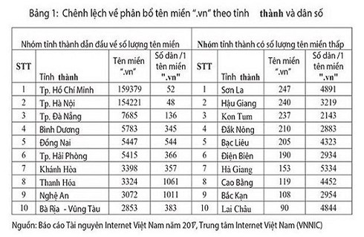

Nowadays, as analysis, as Vietnam E-commerce Association, Vietnam's e-commerce growth rate in 2017 is 25 percent and this rate can increase in period 2018-2020. As “We are social” website, mobile connection rate in Viet Nam is 141% as total population. In the other hand, 33% digital user search or buy products via her/his smartphone in Jan,2014. For which, 16% Vietnamese phone user search for contents based on location on his/her smartphone. So, there is no e-commerce shopping application/website allow user can search products/store based on user’s current location.

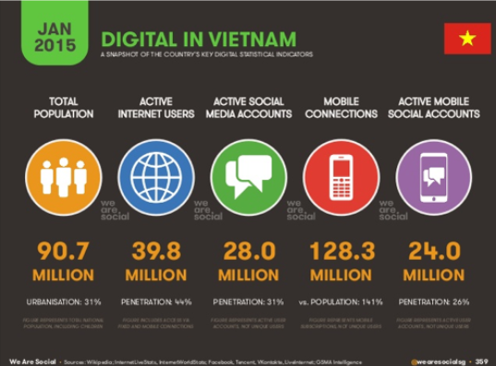

**Số liệu thống kê về xu hướng sử dụng phương thức kĩ thuật số ở Việt Nam năm 2015**

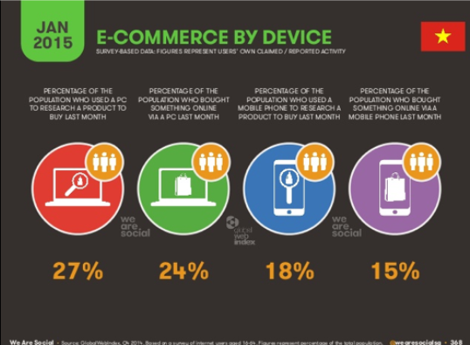

**Số liệu thống kê về xu hướng mua sắm trực tuyến ở Việt Nam tháng 12 năm 2014**

As Director of Consumer Behaviour Research of Nielsen INC, e-commerce in Vietnam has not reached the expected due to user concerned about the quality of goods, long shipment time,..

E-commerce shopping has some advantages are convenient, every-when-buying, easy payment. But, it also has many disadvantage hard to check product’s quality, hard to check store’s service, long shipment time, so on.

## The capstone aim

The aim of this capstone project is to design and develop an E- Shopping Application, on which End-user can search for products such as housewares, customer goods, electronics, .. and order it through nearby store related to their current location. The store can not only add new products, remove and change price and promotion of products, but also to accept or to decline the ordering.

## Literature review of existing system

### Name of current system\

* Shopee: a shopping application which belongs to Garena – a consumer Internet platform provider based in Asia. This application allows user register virtual store in system. The end-user not only can search so many kinds of product through Search box or category, but also to order these products through registered virtual store.
* Lazada: a shopping application which belongs to Alibaba – one of top 10 most valuable and biggest companies in the world. This application allows end-user search products, view products as category, order products through before-registered virtual stores.
* Groupon: an electronic commerce shopping application which belongs to Groupon Inc. This application has same basic function as other e- commerce shopping applications such as: search products, order products, register store, …. Groupon app, in other hand, have a unique function which is locate nearby store to user’s current location.

### Strength of existing system

1. Shopee
   * Large community.
   * Colourful, nice user-interface, great user-experience.
   * Promotion programs are usually, attractive.
   * Support website platform.
   * User can comment, rate and report to virtual stores.
2. Lazada
   * Large community.
   * Nice user-interface, great user-experience.
   * Promotion programs are usually, attractive.
   * Support website platform.
   * User can comment, rate and report to virtual stores.
   * Have some kinds of genuine.
3. Groupon
   * Colourful, nice user-interface, great user-experience.
   * Promotion programs are usually, attractive.
   * Support website platform.
   * Unique function: locate nearby store to user’s current location.

### Weakness of existing system

1. Shopee
   * Management virtual store is hard.
   * Sources of product are uncensored.
   * Shipment time is usually long.
   * Hard to find nearby stores to user’s current location.
2. Lazada
   * Management virtual store is hard.
   * Sources of product are uncensored.
   * Shipment time is usually long.
   * Hard to find nearby stores to user’s current location.
3. Groupon
   * User cannot report to virtual stores.
   * Application do not work in Viet Nam

### To acquire knowledge

1. Shopee + Lazada

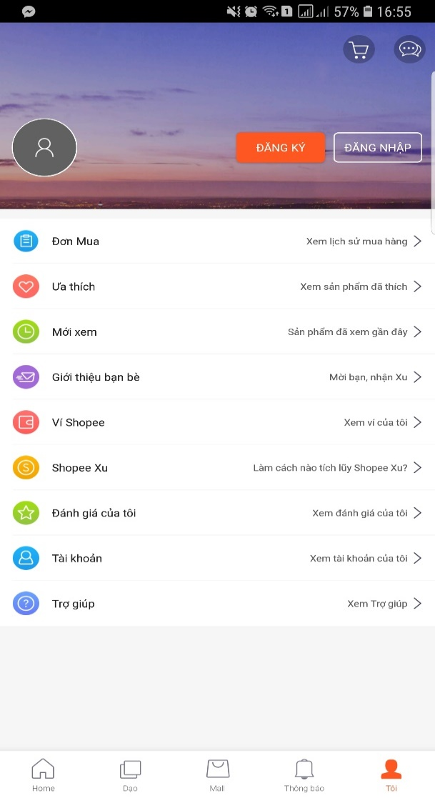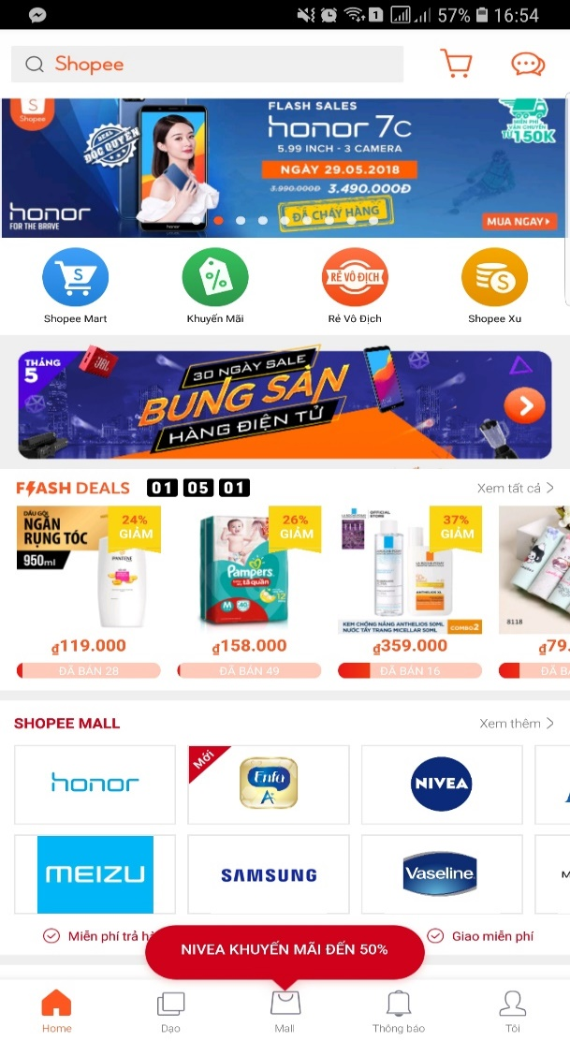

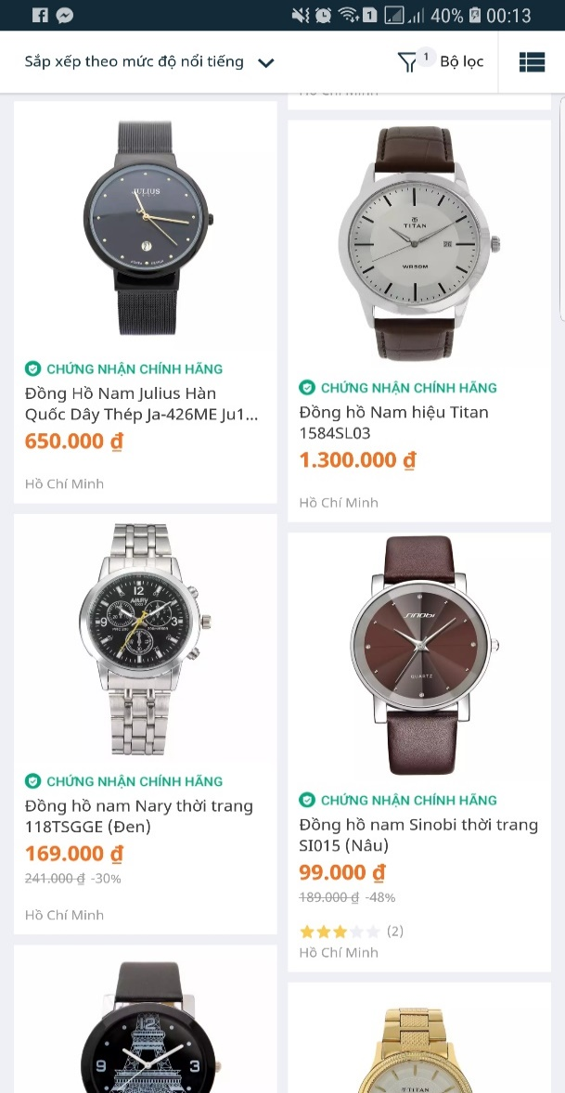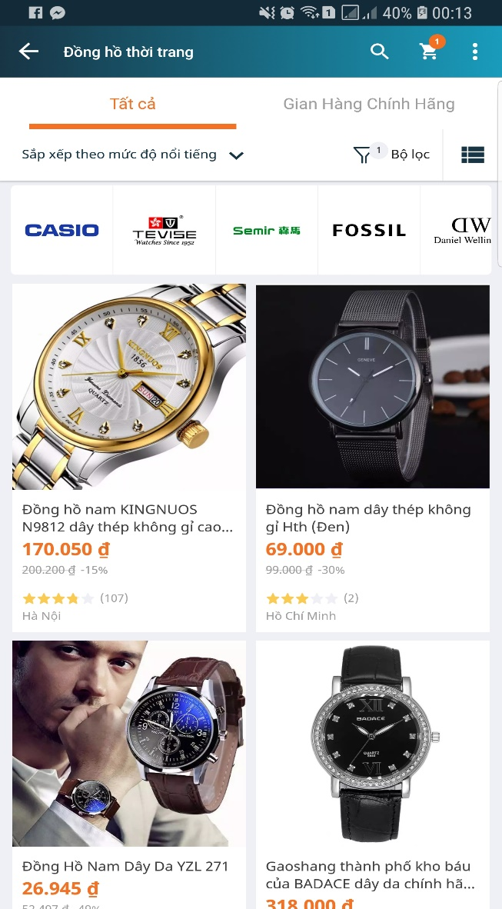

We can learn more from user-interface; how to arrange components in application screen; how ordering business works; how to display products, categories, product details in colorful, clearly layout.

1. Grab

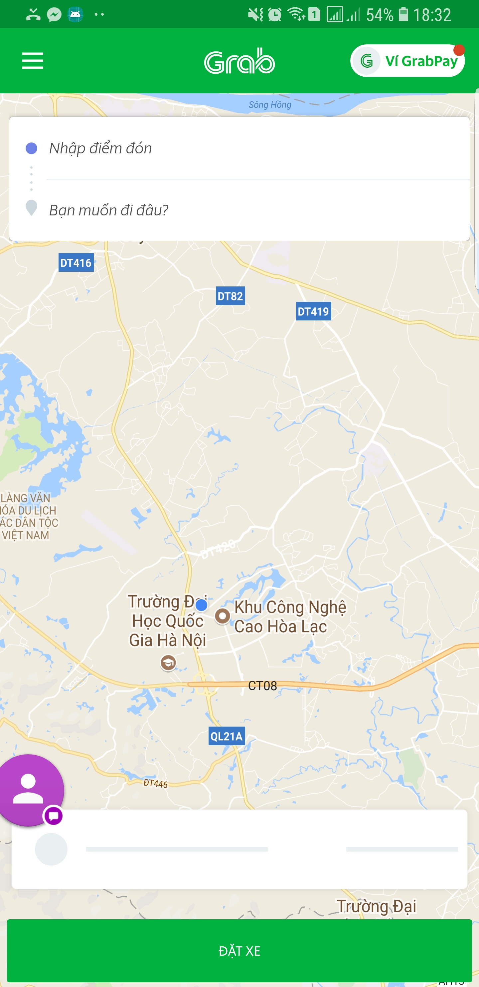

We have learned how the application locate user’s current location, how application identify nearby target to user’s current location in local map, how application direct the way to target.

1. Groupon (Website version)

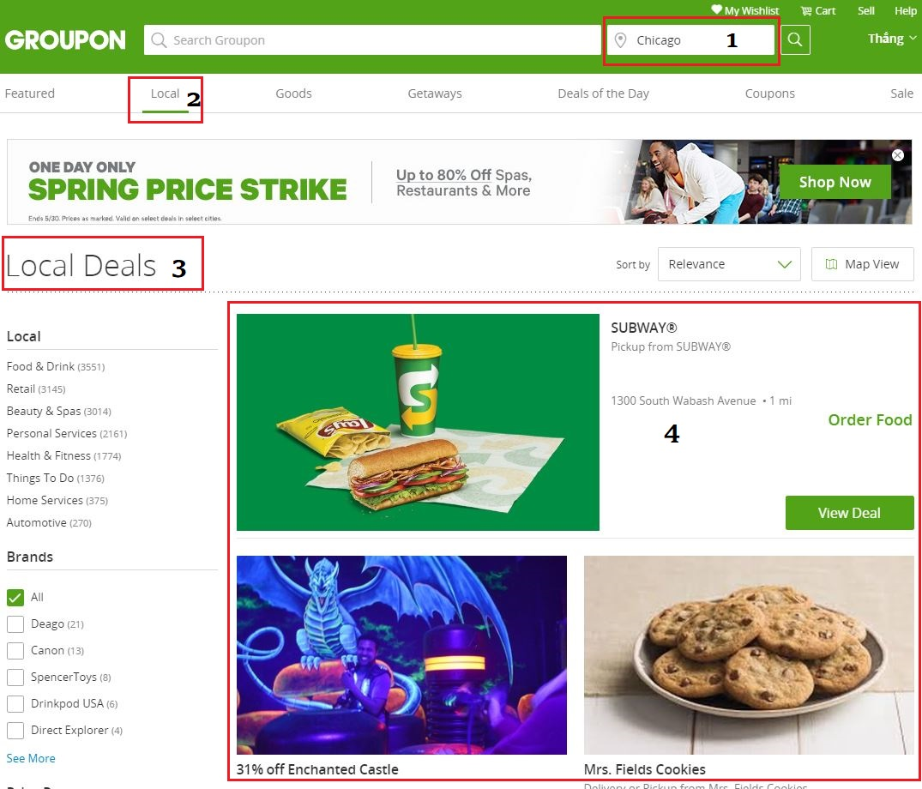We have learned how the application identify nearby target deals to current chosen place (location), how the application identify chosen place (location).

## Our Proposal

1. Ideas
   * To support end-user can find nearest store to order products.
   * To minimize product delivery time to end-user.
   * Remove direct payment because the development time is limit. In the other hand, the application finds nearby store which have user-needed-products to recommend so the distance between end-user and store is usually short. Recommend to use COD payment.
   * To support end-user can find nearby store to user’s current location, in case, user have arrived to strange place (location).
2. Advantages
   * Easy to search (find) products which they need.
   * Easy to order products through nearby store to their current location.
   * Easy to register store, but this registration will be close censored.
   * Convenient to find nearby store address to user’s current location when user have arrived strange place.
3. Disadvantages
   * To not have directly online payment yet.
   * Hard to control spam ordering (in case, after sending ordering product, end-user cancel these ordering).
4. Expectations
   * To have a platform to connect stores with users.
   * To make user convenient, happy in buying products.
   * To make store easy to advertise, approach to user.